Assignment no: 6
Single MultiLevel Multiple Hybrid
Person Person Math1 Math2 Shape
| | | | |
| | --------- -----------------
Student Student | | | |
| Calculator Circle Rectangle Triangle
|
HCPStudent
Diamond
A
|
---------
| |
B C
----------
|
D

1.Create a base class Shape and derive three classes Circle, Rectangle, and Triangle from it. Implement the area() function using run-time polymorphism.
Base Class: Shape
Data Members:
string shapeName
Member Functions:
void acceptShapeName()
void displayShapeName()
virtual void area()
Derived Class: Circle
Data Members:
float radius
Member Functions:
void accept()
void area() — calculate and display the area of the circle.
Formula:
Area = π × radius × radius
Derived Class: Rectangle
Data Members:
float length
float width
Member Functions:
void accept()
void area() — calculate and display the area of the rectangle.
Formula:
Area = length × width
Derived Class: Triangle
Data Members:
float base
float height
Member Functions:
void accept()
void area() — calculate and display the area of the triangle.
Formula:
Area = 0.5 × base × height
Requirements
Use inheritance to derive the three classes from Shape.
Declare area() as a virtual function in the base class.
Override area() in every derived class.
Create a Shape* pointer.
Assign the address of each derived-class object to the base-class pointer.
Call area() through the base-class pointer to demonstrate run-time polymorphism.
#include <iostream>
#include <string>

using namespace std;

// Base Class
class Shape {
protected:
string shapeName;

public:
void acceptShapeName() {
cout << "Enter shape name: ";
cin >> shapeName;
}

void displayShapeName() {
cout << "\nShape: " << shapeName << endl;
}

virtual void area() = 0;

virtual ~Shape() {}
};

class Circle : public Shape {
private:
float radius;

public:
void accept() {
acceptShapeName();
cout << "Enter radius of the circle: ";
cin >> radius;
}

void area() override {
displayShapeName();
float a = 3.14159f * radius * radius;
cout << "Area of Circle: " << a << endl;
}
};

class Rectangle : public Shape {
private:
float length;
float width;

public:
void accept() {
acceptShapeName();
cout << "Enter length of the rectangle: ";
cin >> length;
cout << "Enter width of the rectangle: ";
cin >> width;
}

void area() override {
displayShapeName();
float a = length * width;
cout << "Area of Rectangle: " << a << endl;
}
};

class Triangle : public Shape {
private:
float base;
float height;

public:
void accept() {
acceptShapeName();
cout << "Enter base of the triangle: ";
cin >> base;
cout << "Enter height of the triangle: ";
cin >> height;
}

void area() override {
displayShapeName();
float a = 0.5f * base * height;
cout << "Area of Triangle: " << a << endl;
}
};

int main() {

Shape* shapePtr = nullptr;
int choice;

cout << "Select a shape:\n1. Circle\n2. Rectangle\n3. Triangle\nEnter choice: ";
cin >> choice;

if (choice == 1) {
Circle* c = new Circle();
c->accept();
shapePtr = c;
} else if (choice == 2) {
Rectangle* r = new Rectangle();
r->accept();
shapePtr = r;
} else if (choice == 3) {
Triangle* t = new Triangle();
t->accept();
shapePtr = t;
} else {
cout << "Invalid choice!" << endl;
return 1;
}

shapePtr->area();

delete shapePtr;

return 0;
}

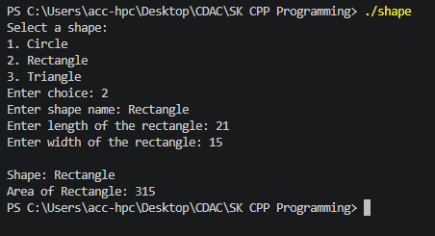

Question 2: Employee Salary Using Run-Time Polymorphism
Create a base class Employee and derive Manager, Developer, and SalesEmployee classes from it. Calculate the salary of each employee using function overriding and run-time polymorphism.
Base Class: Employee
Data Members:
int employeeId
string employeeName
double basicSalary
Member Functions:
void accept()
void display()
virtual double calculateSalary()
Derived Class: Manager
Data Members:
double allowance
Member Functions:
void accept()
double calculateSalary()
Formula:
Salary = Basic Salary + Allowance
Derived Class: Developer
Data Members:
double bonus
Member Functions:
void accept()
double calculateSalary()
Formula:
Salary = Basic Salary + Bonus
Derived Class: SalesEmployee
Data Members:
double salesAmount
double commissionRate
Member Functions:
void accept()
double calculateSalary()
Formula:
Salary = Basic Salary + (salesAmount*commissionRate)
Requirements
Create an Employee* base-class pointer.
Create objects of Manager, Developer, and SalesEmployee.
Store the address of each derived object in the base-class pointer.
Invoke calculateSalary() using the base-class pointer.
Demonstrate run-time polymorphism.
#include <iostream>
#include <string>
#include <iomanip>

using namespace std;

class Employee {
protected:
int employeeId;
string employeeName;
double basicSalary;

public:
virtual ~Employee() {}

virtual void accept() {
cout << "Enter Employee ID: ";
cin >> employeeId;
cin.ignore();
cout << "Enter Employee Name: ";
getline(cin, employeeName);
cout << "Enter Basic Salary: ";
cin >> basicSalary;
}

virtual void display() const {

cout << "Employee ID : " << employeeId << endl;
cout << "Employee Name : " << employeeName << endl;
cout << "Basic Salary : " << fixed << setprecision(2) << basicSalary << endl;
}

virtual double calculateSalary() {
return basicSalary;
}
};

class Manager : public Employee {
private:
double allowance;

public:
void accept() override {
Employee::accept();
cout << "Enter Allowance: ";
cin >> allowance;
}

double calculateSalary() override {
return basicSalary + allowance;
}

void display() const override {
Employee::display();
cout << "Allowance : " << allowance << endl;
cout << "Total Salary : " << const_cast<Manager*>(this)->calculateSalary() << endl;

}
};

class Developer : public Employee {
private:
double bonus;

public:
void accept() override {
Employee::accept();
cout << "Enter Bonus: ";
cin >> bonus;
}

double calculateSalary() override {
return basicSalary + bonus;
}

void display() const override {
Employee::display();
cout << "Bonus : " << bonus << endl;
cout << "Total Salary : " << const_cast<Developer*>(this)->calculateSalary() << endl;

}
};

class SalesEmployee : public Employee {
private:
double salesAmount;
double commissionRate;

public:
void accept() override {
Employee::accept();
cout << "Enter Total Sales Amount: ";
cin >> salesAmount;
cout << "Enter Commission Rate: ";
cin >> commissionRate;
}

double calculateSalary() override {
return basicSalary + (salesAmount * commissionRate);
}

void display() const override {
Employee::display();
cout << "Sales Amount : " << salesAmount << endl;
cout << "Commission : " << (salesAmount * commissionRate) << endl;
cout << "Total Salary : " << const_cast<SalesEmployee*>(this)->calculateSalary() << endl;

}
};

int main() {
const int count = 3;
Employee* emp[count] = { nullptr };
int choice;

cout << " Employee Salary Processing System " << endl;

for (int i = 0; i < count; i++) {
cout << "\nSelect Employee Type for Record #" << (i + 1) << ":" << endl;
cout << "1. Manager\n2. Developer\n3. Sales Employee\nEnter choice (1-3): ";
cin >> choice;

switch (choice) {
case 1:
emp[i] = new Manager();
break;
case 2:
emp[i] = new Developer();
break;
case 3:
emp[i] = new SalesEmployee();
break;
default:
cout << "Invalid choice! Defaulting to basic Employee." << endl;
emp[i] = new Employee();
break;
}

emp[i]->accept();
}

cout << " DISPLAYING SALARY DETAILS " << endl;

for (int i = 0; i < count; i++) {
if (emp[i] != nullptr) {
emp[i]->display();
}
}

for (int i = 0; i < count; i++) {
delete emp[i];
emp[i] = nullptr;
}

return 0;
}
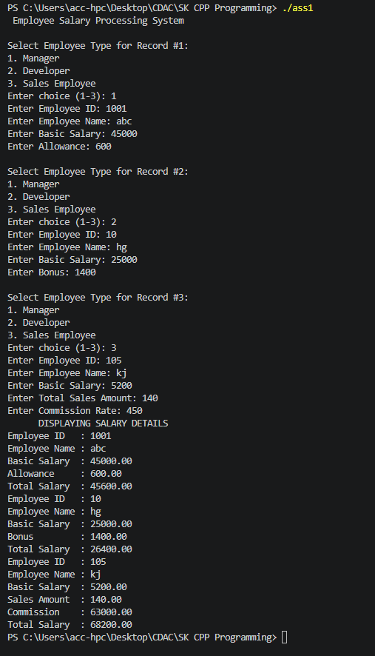

Assignment 7

1 Create a Banking Management System using object-oriented programming concepts.
Create a base class Account containing account number, customer name, and balance.
Derive classes SavingsAccount and CurrentAccount from Account.
Implement functions such as deposit(), withdraw(), and displayAccountDetails().
Override the withdraw() function in both derived classes to demonstrate runtime polymorphism.
Use a base-class pointer to call the appropriate derived-class functions.
Apply the following validations using exception handling:
Attempt to withdraw an amount greater than the available balance.
Deposit amount should be greater than zero.
Withdraw amount should be greater than zero.
Account number should be valid.
Create and handle appropriate user-defined exceptions.
#include<iostream>
using namespace std;

class AccountException:public exception{
string msg;
public:
AccountException(const char*s)
{
msg=s;
}
string what()
{
return msg;
}
};

class Account{
private:
int accno;
string name;
protected:
double balance;
public:
Account()
{
accno=0;
name=" ";
balance=0.0;
}
Account(int accno,string name,double balance)
{
this->accno=accno;
this->name=name;
this->balance=balance;
}
virtual void Deposit(int)=0;
virtual void withdraw(int)=0;
int getaccno(){
return accno;
}
void displayAccountDetails()
{
cout<<"Account No:"<<accno<<endl;
cout<<"Customer Name:"<<name<<endl;
cout<<"Account Balance:"<<balance<<endl;

}
};

class SavingsAccount:public Account{
public:
SavingsAccount(int ac,string n,double b):Account(ac,n,b)
{

}
void Deposit(int amount)
{
if(amount<=0)
{
throw AccountException("Deposit amount should be greater than zero.");
}
balance=balance+amount;
cout<<"Total balance:"<<balance<<endl;
cout<<"Deposit successfull"<<endl;
}
void withdraw(int amount)
{
if(amount<=0)
{
throw AccountException("Withdraw amount should be greater than zero.");
}
if(amount>balance)
{
throw AccountException("Attempt to withdraw an amount greater than the available balance.");

}
balance=balance-amount;
cout<<"Total balance:"<<balance<<endl;
cout<<"withdraw successfull"<<endl;
}
};
class CurrentAccount:public Account{

public:
CurrentAccount(int ac,string n,double b):Account(ac,n,b)
{

}
void Deposit(int amount)
{
if(amount<=0)
{
throw AccountException("Deposit amount should be greater than zero.");
}
balance=balance+amount;
cout<<"Total balance:"<<balance<<endl;
cout<<"Deposit successfull"<<endl;
}
void withdraw(int amount)
{
if(amount<=0)
{
throw AccountException("Withdraw amount should be greater than zero.");
}
if(amount>balance)
{
throw AccountException("Attempt to withdraw an amount greater than the available balance.");

}
balance=balance-amount;
cout<<"Total balance:"<<balance<<endl;
cout<<"withdraw successfull"<<endl;
}
};
int main()
{
Account *ac[10];
int cnt=0;
int choice=0;
do{
cout<<"1.Create Account"<<endl;
cout<<"2.Deposite :"<<endl;
cout<<"3.Withdraw :"<<endl;
cout<<"4.Display account details :"<<endl;
cout<<"Enter Your choice :";
cin>>choice;

switch (choice)
{
case 1: {
int accono;
string name1;
double initialbal;
cout<<"Which account do you want to create : \n 1. Saving account \n 2. current Account ";
int ch;
cin>>ch;
cout<<"Enter account number :";
cin>>accono;
cout<<"Enter Your name :";
cin>>name1;
cout<<"Enter initial balance :";
cin>>initialbal;
switch (ch)
{
case 1:
ac[cnt]=new SavingsAccount(accono,name1,initialbal);
cnt++;
break;

case 2:
ac[cnt]=new CurrentAccount(accono,name1,initialbal);
cnt++;
break;
}}
break;
case 2:{
int accno;
double amount;
cout<<"Enter account number :";
cin>>accno;
for(int i=0;i<cnt;i++)
{
if(ac[i]->getaccno()==accno){
cout<<"Enter amount to deposite :";
cin>>amount;
try{
ac[i]->Deposit(amount);
}
catch(AccountException &a){
cout<<"ERROR: "<<a.what()<<endl;
}
}
}
}break;
case 3:
{
int accno;
int amount;
cout << "Enter Account Number: ";
cin >> accno;

for(int i = 0; i < cnt; i++)
{
if(ac[i]->getaccno() == accno)
{
cout << "Enter Withdraw Amount: ";
cin >> amount;

try
{
ac[i]->withdraw(amount);
}
catch(AccountException &e)
{
cout << "Error: " << e.what() << endl;
}
}
}
break;
}
case 4:
{
int accno;
cout << "Enter Account Number: ";
cin >> accno;
for(int i = 0; i < cnt; i++)
{
if(ac[i]->getaccno() == accno)
{
ac[i]->displayAccountDetails();
break;
}
}
}
break;
case 5:
cout<<"Exit Successfully"<<endl;
break;
default:
cout<<"Invalid choice";
}
}while(choice!=5);
return 0;
}

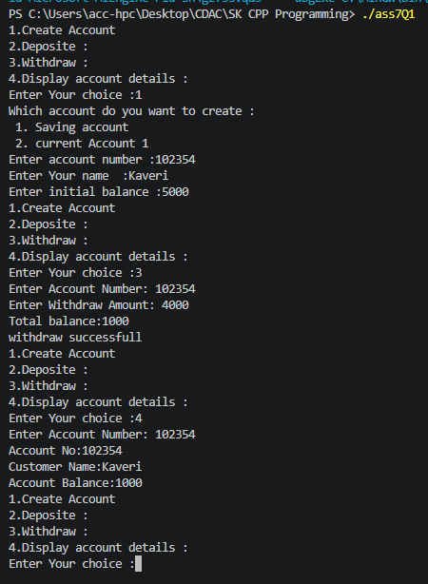

2. Array Index Validation Write a C++ program to create an integer array of size 10. Accept an index from the user and display the element at that index. If the user enters an index outside the valid range 0–9, throw an exception. Requirements: Create an array of 10 integers. Accept an index from the user. Use try, throw, and catch. Display the corresponding element for a valid index. Display "Invalid Array Index" for an invalid index.

#include<iostream>
using namespace std;
int main()
{
int a[10]={1,4,7,4,3,3,4,7,8,9};
int indexvalue;
try
{
cout<<"Enter array index:"<<endl;
cin>>indexvalue;
if(indexvalue<0 || indexvalue >10)
{
throw out_of_range("array index out of bound exception");
}
cout<<"value at "<<indexvalue<<" is :"<<a[indexvalue];

}
catch(out_of_range e)
{
cout<<"ERROR: "<<e.what();
}
return 0;
}

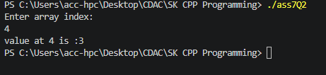

3. Friend Class Box and BoxCalculator Suppose the Box class contains private dimensions. We want another class, BoxCalculator, to access those private members and calculate the volume. Box ---------------- private: length width height | | friend ↓ BoxCalculator ---------------- calculateVolume()

#include <iostream>
using namespace std;
class Box;
class Box {
private:
int length;
int width;
int height;
public:
Box(int l, int w,int h)
{
length=l;
width=w;
height=h;
}
friend class BoxCalculator;
};
class BoxCalculator {
public:
int calculateVolume(const Box &b) {
return b.length * b.width * b.height;
}
};
int main() {

Box myBox(6, 7, 5);
BoxCalculator b1;
double volume = b1.calculateVolume(myBox);
cout << "The volume of the box is: " << volume <<endl;
return 0;
}

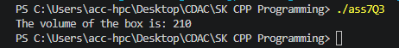

4. Employee Salary Using Run-Time Polymorphism Create a base class Employee and derive Manager, Developer, and SalesEmployee classes from it. Calculate the salary of each employee using function overriding and run-time polymorphism. Base Class: Employee Data Members: int employeeId string employeeName double basicSalary Member Functions: void accept() void display() virtual double calculateSalary() Derived Class: Manager Data Members: double allowance Member Functions: void accept() double calculateSalary() Void assignTask() Formula: Salary = Basic Salary + Allowance Derived Class: Developer Data Members: double bonus Member Functions: void accept() double calculateSalary() Void resolveBugs() Formula: Salary = Basic Salary + Bonus Derived Class: SalesEmployee Data Members: double salesAmount double commissionRate Member Functions: void accept() double calculateSalary() Formula: Salary = Basic Salary + (salesAmount*commissionRate) Requirements Create an Employee* base-class pointer. Create objects of Manager, Developer, and SalesEmployee. Store the address of each derived object in the base-class pointer. Invoke calculateSalary() using the base-class pointer. Demonstrate run-time polymorphism.
#include<iostream>
using namespace std;
class Employee
{
private:
int employeeId;
string employeeName;

protected:
double basicSalary;
public:
Employee()
{
employeeId=0;
employeeName="";
basicSalary=0;
}
virtual void accept()
{

cout<<"Enter Employee Name:";
cin>>employeeName;
cout<<"Enter Basic Salary:";
cin>>basicSalary;
}
virtual void Display()
{
static int count=100;
employeeId=count++;
cout<<" \nId:"<<employeeId<<endl;
cout<<" Name:"<<employeeName<<endl;
cout<<" Basic Salary:"<<basicSalary<<endl;
}
virtual double calculateSalary()=0;

};
class Manager: public Employee
{
private:
double allowance;
public:
Manager()
{
allowance=0;
}
void accept()
{
Employee::accept();
cout<<"Enter allowance:";
cin>>allowance;
}
void Display()
{
cout<<"\n========MANAGER==============";
Employee::Display();
cout<<"Allowance:"<<allowance;

}
double calculateSalary()
{
return basicSalary+allowance;
}
void assignTask()
{
cout<<"Manager is assigning the task:";
}
};
class Developer:public Employee{
private:
double bonus;
public:
Developer()
{
bonus=0;
}
void accept()
{
Employee::accept();
cout<<"Enter bonus:";
cin>>bonus;
}
void Display()
{
cout<<"\n========DEVELOPER==============";
Employee::Display();
cout<<"Bonus:"<<bonus<<endl;
}
double calculateSalary()
{
return basicSalary+bonus;
}
void resolveBugs()
{
cout<<"Developer is resolving task";
}
};
class SalesEmployee:public Employee{
private:
double salesAmount;
double commissionrate;
public:
SalesEmployee()
{
salesAmount=0;
commissionrate=0;
}
void accept()
{
Employee::accept();
cout<<"Enter salesAmount:";
cin>>salesAmount;
cout<<"Enter commision Rate:";
cin>>commissionrate;
}
void Display()
{
cout<<"\n========sALESEMPLOYEE==============";
Employee::Display();
cout<<"Sales Amount:"<<salesAmount<<endl;
cout<<"commision Rate:"<<commissionrate<<endl;
}
double calculateSalary(){
return basicSalary+(salesAmount*commissionrate);
}

};
int main()
{
Employee *emp[10];
int choice;
int cnt=0;

do{
cout<<"\n1.Manager Information";
cout<<"\n2.Developer Information";
cout<<"\n3.Sales Employee Information";
cout<<"\n4.Employee Working Status";
cout<<"\n5.Exit";
cout<<"\n Enter your choice:";
cin>>choice;

switch(choice)
{
case 1:
emp[cnt]=new Manager();
emp[cnt]->accept();
emp[cnt]->Display();
cout<<"\nsalary="<<emp[cnt]->calculateSalary();
cnt++;
break;
case 2:
emp[cnt]=new Developer();
emp[cnt]->accept();
emp[cnt]->Display();
cout<<"salary="<<emp[cnt]->calculateSalary();
cnt++;
break;
case 3:
emp[cnt]=new SalesEmployee();
emp[cnt]->accept();
emp[cnt]->Display();
cout<<"\nsalary="<<emp[cnt]->calculateSalary();
cnt++;
break;
case 4:
for(int i=0;i<cnt;i++)
{

Manager *m=dynamic_cast<Manager*>(emp[i]);
if(m!=nullptr)
{
m->assignTask();
}
Developer *m1=dynamic_cast<Developer*>(emp[i]);
if(m1!=nullptr)
{
m1->resolveBugs();
}
}
break;
case 5:
cout<<"Exit successfully";
default:
cout<<"Invalid choice";
}
}while(choice!=5);

return 0;
}

